Survey Implementation

Document

Using the Translations Worksheet

and Other Workbook Features

of the Feed the Future

ZOI Survey Questionnaire

February 2018

This publication was prepared for review by the United States Agency for International Development. It was prepared by ICF for the United States Agency for International Development, USAID Contract Number GS-23F-8144H/AID-OAA-M-12-00006.

**Recommended Citation**

Jasbir Kaur (adapted from the Demographic and Health Surveys). 2018.

*Feed the Future Zone of Influence Surveys: Using the Translations Worksheet and Other Workbook Features of the Feed the Future ZOI Survey Questionnaire.*

Washington, DC: Bureau for Food Security, USAID

**Contact Information**

Feed the Future

United States Agency for International Development

1300 Pennsylvania Ave, NW

Washington, DC 20004

[www.feedthefuture.gov](http://www.feedthefuture.gov)

**Table of Contents**

1. Background 1

2. Basic features of worksheet questionnaire design 1

3. Translations worksheet 3

4. Language of the questionnaire 6

5. Adding new questions 6

6. Deleting questions 7

7. Editing questions 7

7.1 Truncated text 7

7.2 Displaying numbers 8

7.3 Dot leaders 9

7.4 Question text space displays #N/A 10

8. Making global changes 10

9. Skip arrows and boxes 10

10. Version control 11

Appendix A: Printing 13

**List of Figures**

Figure 1: Questionnaire Layout 1

Figure 2: Questionnaire Layout for Multiple Respondents 2

Figure 3: Excel Worksheets 2

Figure 4: Page Break View 2

Figure 5: Translations Tab 3

Figure 6: Translations Sheet Layout 3

Figure 7: Languages on Translations Sheet 4

Figure 8: Question Formula Type 1 5

Figure 9: Question Formula Type 2 5

Figure 10: Selecting Language for the Questionnaire 6

Figure 11: Highlighting a Question to Copy 6

Figure 12: Inserting Copied Question 7

Figure 13: Example—Cut-off Text 8

Figure 14: Truncated Text 8

Figure 15: Truncated Text Fixed 8

Figure 16: Displaying Numbers 8

Figure 17: Showing Dot Leaders 1 9

Figure 18: Showing Dot Leaders 2 9

Figure 19: Showing Dot Leaders 3 9

Figure 20: Move and Size Skip Arrows and Boxes 11

Figure 21: Changing Shape of the Arrows and Boxes 11

Figure 22: Version Control for Questionnaire and Formatted Languages 12

Figure A1: Selecting Worksheet Tabs for Printing 13

Figure A2: Printing the Worksheets 13

Figure A3: Applying Border for Printing 14

# 1. Background

Feed the Future is the U.S. Government’s global food security initiative that seeks to reduce poverty, hunger, and undernutrition among women and children and to increase resilience, income, women’s empowerment, dietary diversity, and appropriate feeding practices. Feed the Future’s programmatic efforts are concentrated in Zones of Influence (ZOIs) in selected target countries.

Progress in achieving Feed the Future’s objectives is tracked using information collected through representative cluster sample surveys called ZOI Surveys. These surveys are designed to provide estimates for key Feed the Future indicators related to poverty, agriculture, nutrition, hunger, and resilience.

This manual provides detailed instructions on how to use the translation spreadsheet included in the Feed the Future ZOI Survey questionnaire.

# 2. Basic features of worksheet questionnaire design

The Feed the Future ZOI Survey questionnaire has been developed in Excel, which is used here as a kind of digital graph paper. The question numbers, question text, coding categories, skip arrows, and skip instructions are contained in the cells, or the boxes of the virtual graph paper. The lines between questions are simply borders of cells. The boxes in which interviewers record numbers are also cells with a border assigned to them.

Each question is numbered sequentially, and sub-questions also are either lettered or numbered. In Excel, the size, width, height, and number of columns, rows, and cells are used to lay out the questions for printing and are carefully sized. Therefore, it is very important that these not be changed. Each question is separated by a horizontal line. Question numbers, question text and filters, coding categories, and skip instructions are separated by vertical lines (Figure 1).

**Figure 1: Questionnaire Layout**

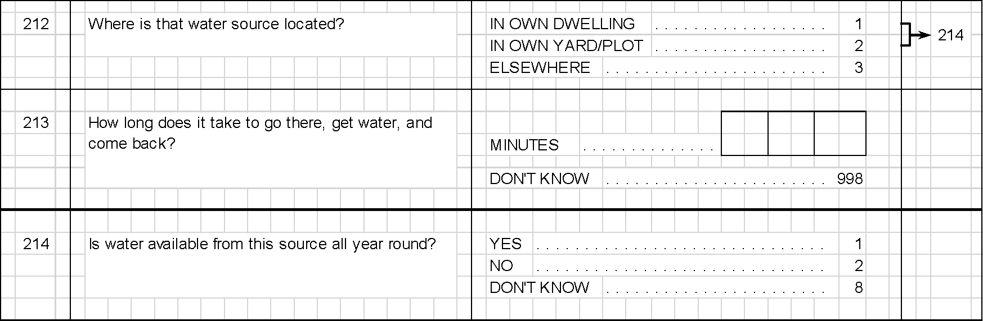

**NOTE:** Do not change column widths. If you change the width of a column, it affects that whole section of the questionnaire. If it is absolutely necessary to change a column width (for example, if you need to create a complicated table similar to the household schedule in the household questionnaire), create a new worksheet for that section and change the width of the columns for that worksheet only.

Some questions are asked of or about multiple people. These questions have one number and multiple columns of coding categories (Figure 2). **Only text in the Question and Filters are translated.**

**Figure 2: Questionnaire Layout for Multiple Respondents**



The questionnaire is made up of several Excel worksheets. In general, each worksheet contains one section of the questionnaire. To move between worksheets, click on the tabs at the bottom of the window (Figure 3).

**Figure 3: Excel Worksheets**



The questionnaires should be viewed in Page Break Preview (View > Page Break Preview). In Page Break Preview, the solid blue lines around the questionnaire indicate page boundaries. Solid lines are manual page breaks (Figure 4). If a dotted line appears, it indicates a soft page break—in other words, where Excel is going to start a new page unless a manual page break is inserted before it. All the page breaks in the questionnaire should be manual page breaks; otherwise, Excel may insert a soft page break in a page that is too long, and it may insert that break in the middle of a question.

**Figure 4: Page Break View**

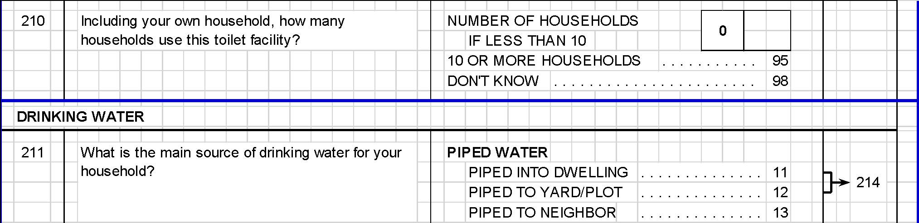

To convert a soft (automatic) page break to a manual page break, click on the dotted blue line and drag it up or down. To move a manual page break, just click on the solid blue line and drag. If you drag it too far down the page, Excel will try to fit too much information on one page and it will automatically reduce the size of the font, which will print out too small to read. See Appendix A for information on correcting this problem.

# 3. Translations worksheet

The text for each question in the questionnaire is entered on the Excel worksheet named “Translations” (Figure 5). Using this approach greatly facilitates the process of producing translated, correctly formatted versions of the questionnaire; it also reduces transcription errors and helps maintain version control across different translated versions of the questionnaire.

**Figure 5: Translations Tab**



The first column in the Translations worksheet is the question number. This should match the number in the questionnaire worksheet. The formula uses this number to link the question text to the correct place in the questionnaire. The text for other languages should be entered in a single cell directly to the right of the corresponding question number. Each row will automatically increase to fit the text (AutoFit Row Height), and the text will automatically wrap to the next line within the cell (Wrap Text) (Figure 6).

**Figure 6: Translations Sheet Layout**

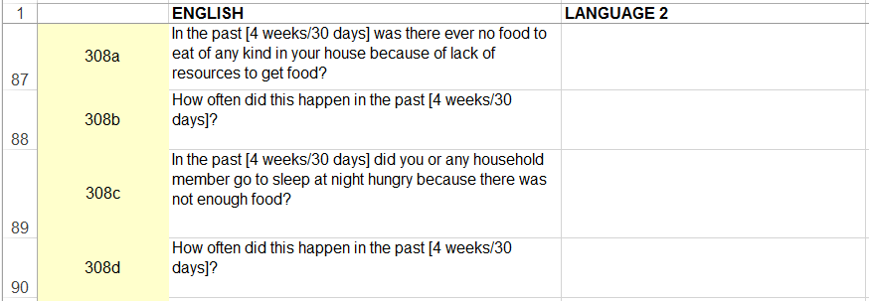

An example of a completed translation is shown in Figure 7. The Translations worksheet can contain one or more translations.

**Figure 7: Languages on Translations Sheet**

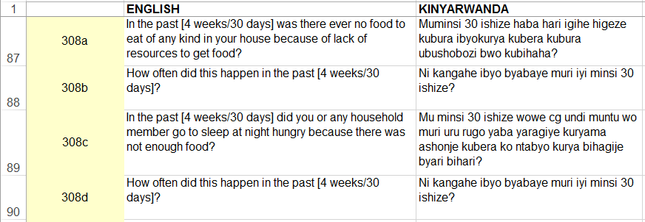

**Two Types of Question Text Formulas**

Formulas are used to populate the space reserved for each question text in the other Excel worksheets in the questionnaire. The formula is the same for most, but not all, questions. The formula uses named ranges to reference the list of all questions (Language_Translations), the selected language (Languages_Selected), and the list of all languages in the questionnaire (Language_Options), which is the same as the languages listed on the cover page. The formula also uses relative cell references using the question location (INDIRECT and ADDRESS functions). Finally, the VLOOKUP function combines all this information to populate the question text. This manual will not go into detail regarding these Excel functions. This section describes each question text formula.

The formula can be pasted directly in the space for a new question as long as the question number is in the same row and exactly three columns to the left of the question space.

**Question Formula Type 1:**

==VLOOKUP(INDIRECT(ADDRESS(ROW(),COLUMN()-3)),Language_Translations,MATCH(Language_Selected,Language_Options,0),FALSE)

The formula matches the question number in the questionnaire worksheet to the same question number in the Translations worksheet. The text is then populated for the selected language. For example, in Figure 8, cell B36 contains the question number 302, and the merged cells E36–T39 contain the formula that populates the cell with the question text.

**Figure 8: Question Formula Type 1**

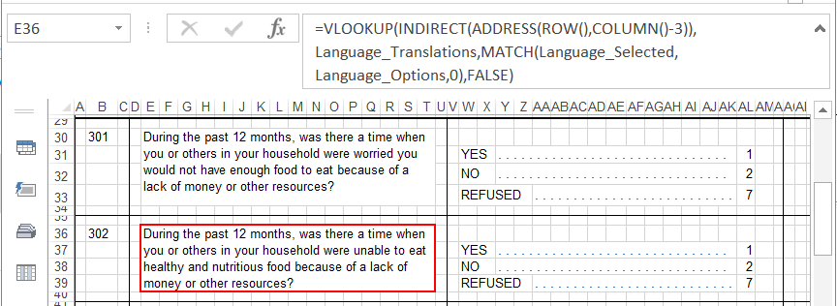

Some questions, such as those in the Women’s Empowerment in Agriculture Index section, are arranged with the question number directly above the question text. For these questions, a slightly different formula is needed. This formula works for questions in which the question number is exactly three rows above and in the same column as the question space.

**Question Formula Type 2:**

=VLOOKUP(INDIRECT(ADDRESS(ROW()-3,COLUMN())),Language_Translations, MATCH(Language_Selected,Language_Options,0),FALSE)

As shown in Figure 9, the question number for 6.404 is located in cell U5, and the question text is located in the merged cells U8–AE11.

**Figure 9: Question Formula Type 2**

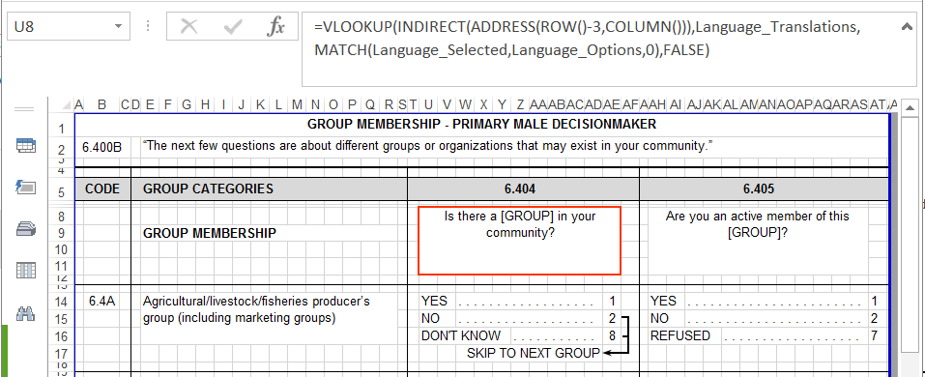

# 4. Language of the questionnaire

The cover page contains a selection box for choosing the language of the questionnaire. Select the merged area with the language name and click the down arrow to change languages. Once selected, the formulas will automatically update the question text using the selected language (Figure 10).

**Figure 10: Selecting Language for the Questionnaire**

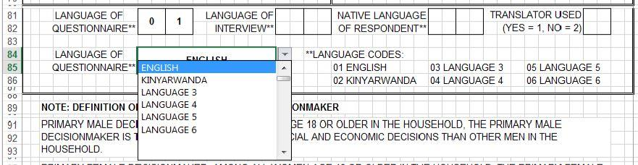

# 5. Adding new questions

To insert a new question, it is best to copy and paste an existing question. Follow these steps:

1. Choose a question to copy that is formatted like the question you want to insert. If you want to insert a question with several coding categories, choose a question with several coding categories. If you want to insert a question that only has responses of YES/NO, choose a question that has responses of YES/NO.
2. Highlight the rows of the question you want to copy (by pointing to the grey row numbers). Highlight the entire rows, not just the cells. Then select copy (Home > Copy, or Ctrl+C) (Figure 11).

**Figure 11: Highlighting a Question to Copy**

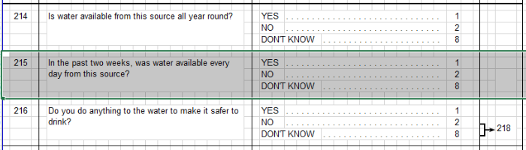

1. Find the question that will come after your new question. Select the first row of it by clicking on the grey row number to the left of the row. It should be one of the rows with a very short height. You may need to zoom in (View > Zoom) to see what you are doing.
2. Right-click anywhere inside the highlighted row and choose “Insert Copied Cells” from the menu (Figure 12).

**Figure 12: Inserting Copied Question**

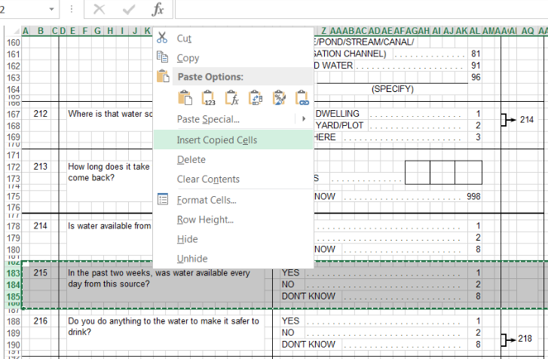

1. Delete the content of the old question (highlight the cells and click on “Delete”) and type in the new question. If you need to delete a row, select the row to be deleted, right-click, and choose “Delete” from the menu. To add a new row, select the row below where you want the new row to appear, right-click, and choose “Insert” from the menu.

# 6. Deleting questions

To delete a question, select all the rows of the question (not just the cells), right-click on the highlighted rows, and choose “Delete” from the menu. Ensure that you also delete the question row on the Translations worksheet using this same method. If you delete a question with a skip arrow and the skip arrow remains, you will have to delete it manually. Select the arrow and click on “Delete.”

# 7. Editing questions

All changes to the question text should also be made on the Translations worksheet. When adding a new question, first add it to the questionnaire and add a line with the same question number to the Translations worksheet. To edit question text that is already in the questionnaire, find the row in the Translations worksheet that contains that question number and change the text in that cell.

## 7.1 Truncated text

Excel allows text in an unmerged cell to overlap the cells to its right, as long as nothing else is contained in the cells being overlapped. If one of the cells that the text is “covering up” has something in it, Excel will display that instead. For example, as shown in Figure 13, the words ANIMAL-DRAWN CART appear to be cut off. This is because cell AB366 has a space typed in it. Excel displays the space and cuts off any text running over from the text entered in cell X366. To solve the problem, simply select the cell where the text ends—AB366 in this case—and click on “Delete” to delete the space. The full contents of cell X366 will then be displayed.

**Figure 13: Example—Cut-off Text**

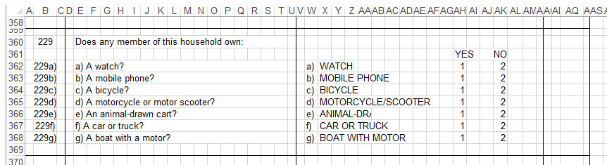

Merged cells, however, do not allow the text to overlap adjacent cells, even if those adjacent cells are empty. Text in merged cells can be displayed in the merged area only. If a merged cell is not large enough for the text, insert a new row just above the last row for that question. For example, as shown in Figure 14, the question text for question 301 is truncated.

**Figure 14: Truncated Text**



Insert a new row above row 32 and merge the question area with the new row. The question text is now contained in three rows instead of two and is fully visible (Figure 15).

**Figure 15: Truncated Text Fixed**

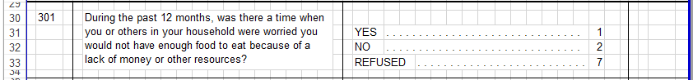

## 7.2 Displaying numbers

Excel will display “#” instead of the number that is contained in the cell if the column width is not wide enough for the number and the cell format is set to “Number” or “General” (Figure 16). To fix this, select the cell with “#,” change the format to “Text,” and then re-enter the number. Alternatively, you can enter an apostrophe followed by the number (e.g., ‘999998). This automatically formats the number as text.

**Figure 16: Displaying Numbers**

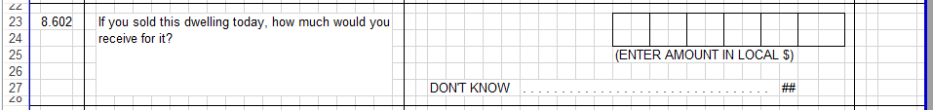

All question numbers should be formatted as numbers. If the question number is formatted between the questionnaire and the Translations worksheet, this will cause an error in the translation formula.

Another related problem is that Excel will display “01” as “1” if the cell format is set to anything other than text. Use the two ways described above to solve this problem. The easiest way is to simply enter the number with a preceding apostrophe (e.g., ’01); the apostrophe will not be displayed, but the leading zero will be.

## 7.3 Dot leaders

The row of dots leading to a category number (called a *dot leader*) is created using only one dot, one space, and a special setting in the Home > Alignment dialog box. Follow these steps to create the dot leaders.

1. Type “. ” (a period or full stop, followed by a space) in the first empty box to the right of the text. To avoid problems printing the questionnaire, make sure that the cell with the dot leader does not overlap the text to its left.
2. Select that cell and all the blank cells to its right, up to the coding category itself (Figure 17).

**Figure 17: Showing Dot Leaders 1**

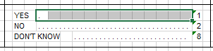

1. Go to Home > Alignment and click on the more arrow (Figure 18).

**Figure 18: Showing Dot Leaders 2**

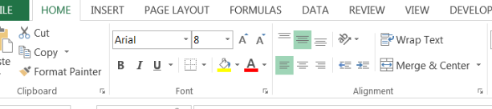

1. Under “Alignment,” choose “Fill” from the “Horizontal” drop-down menu (Figure 19).

**Figure 19: Showing Dot Leaders 3**

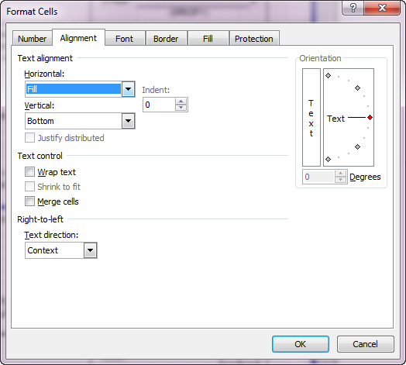

## 7.4 Question text space displays #N/A

Every question in the questionnaire must have a corresponding line in the Translations worksheet. If questions are renumbered or new questions are added, it is necessary to update the Translations worksheet. The question number in the questionnaire must match the question number in the Translations worksheet. Question numbers are formatted as “General,” which stores them as a number and not as text.

If the question displays “#N/A” instead of the question text, this is because the question numbers cannot be found in the translation page of the questionnaire file. Copy the question number and text from the translation page in the original file and paste those cells after the last row with text in the translation page of the questionnaire file. When renumbering the questions, be sure to change the numbers in both the questionnaire section and the Translations worksheet.

# 8. Making global changes

To make changes that affect all the worksheets in a document at once—for instance, to change the header or footer for the entire document—right-click on any of the tabs at the bottom of the screen and choose “Select All Sheets.” **WARNING:** Any changes you make will apply to ALL sheets. This includes changes such as deleting cell contents, so be very careful what you do when multiple sheets are selected. Note that changing the header or footer with all worksheets selected will also apply the same page layout and scaling that are used in the current worksheet, even if you only change the footer. Make global changes sparingly, if ever. It is generally a good idea to save your work before choosing “Select All Sheets” in case you make a change that you did not anticipate and do not want, so you can revert back to the previous version. When you have finished making changes, right-click on any worksheet and select “Ungroup Sheets” from the menu; otherwise, future changes to one worksheet will continue to be made to all grouped worksheets.

# 9. Skip arrows and boxes

The skip arrows and filter boxes are Excel shapes. Simple skip arrows are one single line with an arrow at the end. More complex shapes, such as bracketed skips or filter boxes, are grouped objects. The shapes can be anchored to the cells they are in, which means that they will move and size with that cell. They can also be set to move but not size with the cell, or be set to not move and not size. The skip arrows should all be set to “Move and size with cells” (Figure 20).

**Figure 20: Move and Size Skip Arrows and Boxes**

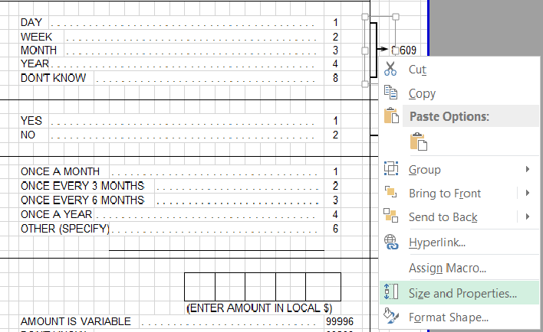

Unless you need a new skip arrow shape, there is no need to create skip arrows from scratch. It is easier to copy a skip arrow or filter box that looks like what you need and modify it. The easiest way to copy and paste shapes is to select the shape, not the cell. To select the shape only, move the mouse over the shape (a skip arrow, for example) and click when the mouse becomes four black arrows (Figure 21).

**Figure 21: Changing Shape of the Arrows and Boxes**

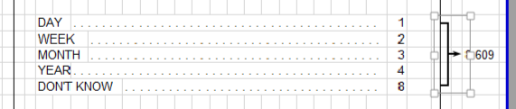

To modify an existing shape (for instance, to shorten the number of coding categories that are bracketed), select the shape and then click and hold a corner. This will resize the skip arrow.

To move individual lines within a bracketed skip arrow, click the skip arrow once to select it, then click again on the part that you want to move. The larger grouped object will be outlined in dashed lines, and the component piece will be selected with white squares at the ends. Using the arrow keys, move the selected piece up or down. To delete a shape, click on it to select it, and click on “Delete.”

# 10. Version control

The questionnaire will require many revisions during the questionnaire design process. Keeping careful records of the multiple files created is critical. Each time you save the Excel file, you should change the name of the file. The standard file name convention is:

[YYYYMMDD]_ZOI SURVEY QUESTIONNAIRE_V[#.#]

For example, 20180214_ZOI SURVEY QUESTIONNAIRE_V1.0

The questionnaire also contains a place for two dates on the cover page. The Formatting Date is the date when changes were last made to the format, order, or structure of the questionnaire. This date should be changed when questions are added, removed, or reordered. The Language Date is populated using a formula. This is the date that is entered on the Translations worksheet and should reflect the latest version of each language (Figure 22).

**Figure 22: Version Control for Questionnaire and Formatted Languages**

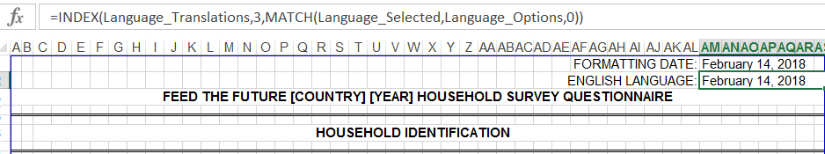

Formulas are used to populate the space reserved for each question text in the other Excel worksheets in the questionnaire. You can select the language on the cover page of the questionnaire, and the formulas will automatically update the question text using the selected language.

# Appendix A: Printing

Rather than printing directly from Excel to a printer, we suggest creating a PDF. There are many free PDF print drivers. To print the entire questionnaire, including the Translations worksheet, go to File > Print, and under the Settings section, choose “Print Entire Workbook,” and then click on “Print.”

To print just the questionnaire, select all worksheets except Translations. Selected worksheets (tabs) will be a lighter color (Figure A1).

**Figure A1: Selecting Worksheet Tabs for Printing**



If you want to print just one section of the questionnaire, you can choose the “Print Active Sheets” button. The page numbering, however, will not reflect the actual questionnaire page numbers. To print just part of the questionnaire with the correct page numbers, go to File > Print, but do not choose “Print Active Sheets.” Instead, choose “Print Entire Workbook,” and then click the pages in preview and determine which page numbers you want to print. When you know what pages you need, enter the page numbers you want under “Pages” and click on “Print” (Figure A2).

**Figure A2: Printing the Worksheets**

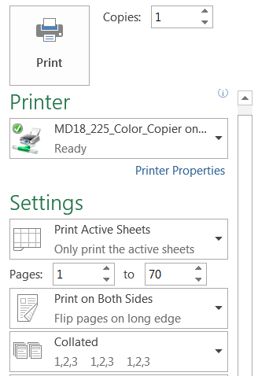

**If the PDF file creation software prompts for multiple files:**

When printing the entire workbook, you may encounter a problem including the Translations worksheet. The print format of these worksheets is set differently from the other worksheets. The PDF creation software will pause the print job at this point, prompting you to create an additional file. If this happens, click on “Cancel” for the second file name prompt. The first print request will create a file with the questionnaire worksheets excluding these two worksheets.

**If skip arrows print in different locations than how they appear on the screen:**

The skip arrows are Excel objects and their placement is determined by the print driver. If the skip arrows are shifting when printing directly to a printer, first create a PDF of the questionnaire in Excel and then print the PDF file. You can use Adobe or any free PDF creator software.

**If the page prints out too small, with very small text, boxes, and arrows:**

If the manual page breaks are too far apart and allow the page to include too many questions, Excel will automatically reduce the scale of the output to fit the page. Under Page Layout, check the Scale. If the scale is less than 100%, change the scale and adjust the page breaks. All worksheets in the Model Questionnaires have been formatted at 100% (except the household schedule) and to fill the maximum space on both an 8.5” x 11” and an A4 piece of paper.

**If the last border on a page shows on screen but does not print:**

Another common printing problem is that the line below a question shows on screen but does not print. The last row before the page break must have a bottom border. If the first row after the page break contains a top border only, the print preview will look correct but the printout will be incorrect. Check the borders by selecting the last row on a page, which is the row just before the page break. Ensure that a bottom border is applied (Figure A3).

**Figure A3: Applying Border for Printing**

